Alice opens the doors
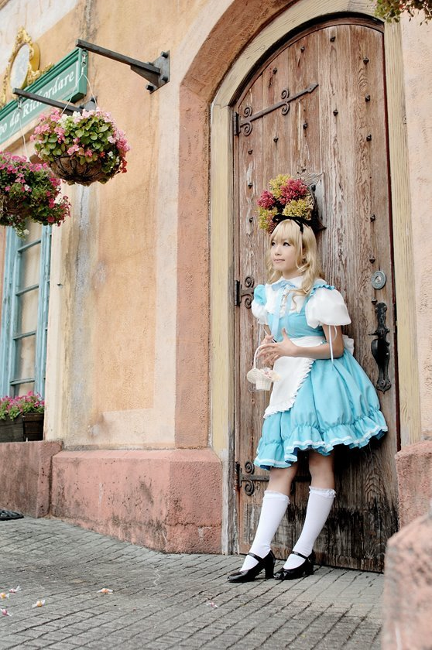
(Adapted from “Alice's adventures in Wonderland” by Lewis Carroll)

Шагина Наталия Валерьевна школа № 29 Василеостровского района города Санкт- Петербурга

Actors: Alice (Алиса)
Duchess (Герцогиня)
two footmen ( Два лакея)
cook ( кухарка)
March Hare (Мартовский Заяц)
Cheshire cat (Чеширский кот)
Hatter (Шляпник)
Dormouse (Соня)
butterfly ( бабочка)

http://lib.ru/CARROLL/alice.txt
Рассказчик: ‘Have you heard about Alice's adventures in Wonderland? So many strange things happened to her on that day. She fell down the rabbit hole, she grew small, she met so many unusual creatures, she swam in the lake of her own tears, she talked to a caterpillar, and finally she came to a house. Let's see what happened then.’

На сцене появляется Алиса. Она идет, оглядываясь по сторонам с удивлением. Вдруг она видит дверь, рядом с которой стоит лакей. На сцену выходит второй лакей с посланием.
Второй лакей: `For the Duchess. An invitation from the Queen to play croquet.'
Первый лакей: `From the Queen. An invitation for the Duchess to play croquet.'
Они раскланиваются, и второй лакей уходит. Алиса подходит к двери и начинает стучать в нее.
Лакей: `There's no sort of use in knocking, and that for two reasons. First, because I'm on the same side of the door as you are; secondly, because they're making such a noise inside, no one could possibly hear you'.
Алиса: `Please, then, how am I to get in?'
Лакей: `There might be some sense in your knocking, if we had the door between us. For instance, if you were INSIDE, you might knock, and I could let you out, you know.'
Алиса: 'How am I to get in?'
Лакей: `I shall sit here, till tomorrow---or next day, maybe,'
Алиса:`How am I to get in?'
Лакей: `ARE you to get in at all?'
Алиса: `It's really dreadful, the way all the creatures argue. It's enough to drive one crazy!'
Лакей: `I shall sit here, on and off, for days and days.'
Алиса: `But what am I to do?'
Лакей: `Anything you like'
Алиса: `Oh, there's no use in talking to him, he's perfectly idiotic!'
Алиса махнула рукой на лакея и открыла дверь (вместо двери ширма).
За дверью: Герцогиня качает младенца, кухарка яростно помешивает суп в кастрюле, подсыпает в него перец и время от времени швыряет тарелки, Чеширский кот улыбается и поигрывает хвостом. Все чихают.
Алиса: `There's certainly too much pepper in that soup!' ( в сторону)
`Please would you tell me, why your cat grins like that?' (Герцогине)
Герцогиня: `It's a Cheshire cat, and that's why.'
Алиса: 'I didn't know that Cheshire cats always grinned; in fact, I didn't know that cats COULD grin.'
`Герцогиня: 'They all can, and most of them do.'
Алиса: `I don't know of any that do'
Герцогиня: `You don't know much, and that's a fact.' (Трясет младенца изо всех сил)
Алиса: `Oh, PLEASE mind what you're doing!'
Герцогиня: `If everybody minded their own business, the world would go round a deal faster than it does.' (Трясет младенца и напевает)
`Speak roughly to your little boy,
And beat him when he sneezes:
He only does it to annoy,
Because he knows it teases’
`Here! You may nurse it a bit, if you like! I must go and get ready to play croquet with the Queen.' (Бросает младенца Алисе.)

Алиса с младенцем на руках выходит из двери. Мимо пролетает тарелка. Младенец хрюкает. Ширма задвигается, и за ней идет приготовление к сцене с «Безумным чаепитием».
Алиса: `Don't grunt, that's not at all a proper way of expressing yourself. 'If you're going to turn into a pig, my dear, I'll have nothing more to do with you. Mind now! '
Младенец превращается в поросенка (в платке завернут игрушечный поросенок), и Алиса выпускает его из рук. Она идет дальше в сторону от двери-ширмы и вдруг видит Чеширского кота. Алиса вкрадчиво начинает с ним разговор.
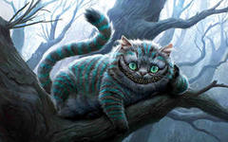
Алиса: Cheshire Puss, `Would you tell me, please, which way I ought to go from here?'
Кот: `That depends a good deal on where you want to get to,'
Алиса: `I don't much care where--'
Кот: `Then it doesn't matter which way you go,'
Алиса: `--so long as I get SOMEWHERE,'
Кот: `Oh, you're sure to do that, if you only walk long enough.'
Алиса: `What sort of people live about here?'
Кот: `In THAT direction lives a Hatter: and in THAT direction, lives a March Hare. Visit either you like: they're both mad.' (Показывает руками направление)
Алиса: `But I don't want to go among mad people
Кот: `Oh, you can't help that, we're all mad here. I'm mad. You're mad.'
Алиса: `How do you know I'm mad?' ( angrily )
Кот: `You must be, or you wouldn't have come here.'
`Do you play croquet with the Queen to-day?
Алиса: `I should like it very much, but I haven't been invited yet.'
Кот: `You'll see me there.’(исчезает)
(Снова появляется) `By-the-bye, what became of the baby? I'd nearly forgotten to ask.'
Алиса: `It turned into a pig,'
Кот: `I thought it would.' (исчезает )
(Снова появляется) `Did you say pig, or fig?'
(Кот "исчезает" и "появляется" при помощи большого темного платка, на котором нарисована улыбка)
Алиса: `I said pig, and I wish you wouldn't keep appearing and vanishing so suddenly: you make on quite giddy.'
Кот: `All right.'
Алиса: `Well! I've often seen a cat without a grin, but a grin without a cat! It's the most curious thing I ever saw in my life!'
Рассказчик: ’ Alice decided to visit March Hare. She decided that it would be more interesting, and perhaps as it was not March it wouldn't be raving mad’.
Алиса подходит к калитке, открывает ее и видит Шляпника, Мартовского Зайца и Соню, сидящих за огромным столом, заставленным чашками, тарелками с пирожками и печеньем. Время от времени они пересаживаются, но чистая чашка достается только Шляпнику. Увидев Алису, все начинают кричать:
`No room! No room!'
Алиса:`There's PLENTY of room!'
Мартовский Заяц:`Have some wine.'
Алиса:`I don't see any wine.'
Мартовский Заяц:`There isn't any.'
Алиса: `Then it wasn't very civil of you to offer it.'
Мартовский Заяц: `It wasn't very civil of you to sit down without being invited.'
Алиса: I didn't know it was YOUR table, it's laid for a great many more than three.'
Шляпник: ‘ Your hair wants cutting.'
Алиса: `You should learn not to make personal remarks it's very rude.'
Шляпник: `What day of the month is it?'
Алиса: `The fourth.'
Шляпник: `Two days wrong! I told you butter wouldn't suit the works!'
Мартовский Заяц: It was the BEST butter, you know.'
Алиса: `What a funny watch!'It tells the day of the month, and doesn't tell what o'clock it is!
Шляпник: `Why should it?'
Все ведут себя очень странно: Мартовский Заяц размешивает сахар в своей чашке ушами, Шляпник поливает Соню из чайника и т.п.
Алиса: `I think you might do something better with the time than waste it in such a way!’
Шляпник: `If you knew Time as well as I do, you wouldn't talk about wasting IT.
Алиса: `I don't know what you mean,'
`Of course you don't! You never even spoke to Time!' We quarrelled last March--just before HE went mad ( указывает в сторону Мартовского Зайца), you know--it was at the great concert given by the Queen of Hearts, and I had to sing
"Twinkle, twinkle, little bat!
How I wonder what you're at!
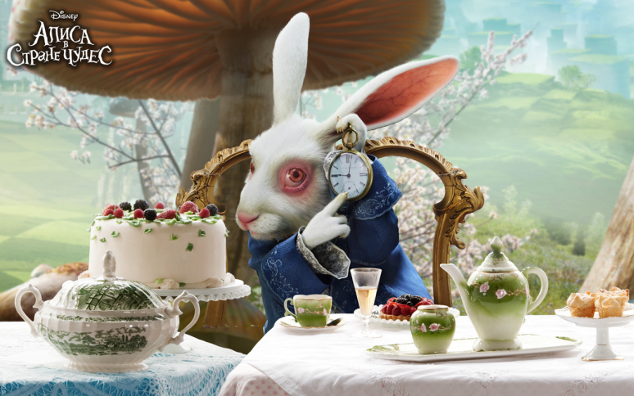
Up above the world you fly,
Like a tea-tray in the sky.
Twinkle, twinkle--"
Соня: ‘Twinkle, twinkle, twinkle, twinkle--'
Шляпник: `Well, I'd hardly finished the first verse, when the Queen jumped up and bawled out, "He's murdering the time! Off with his head!"
Алиса: `How dreadfully savage!'
Шляпник: `And since that It's always six o'clock. It's always tea-time, and we've no time to wash the things between whiles.'
Алиса: `Then you keep moving round, I suppose?'
Шляпник: `Exactly so’.
Алиса: `But what happens when you come to the beginning again?'
Мартовский Заяц: `Suppose we change the subject, I'm getting tired of this. I vote the young lady
tells us a story.'
Алиса: `I'm afraid I don't know one
Мартовский Заяц `Then the Dormouse shall! Wake up, Dormouse!'
Соня:`I wasn't asleep, I heard every word you fellows were saying.'
Мартовский Заяц: `Tell us a story!'
Шляпник: `And be quick about it or you'll be asleep again before it's done.'
Соня:Once upon a time there were three little sisters and they lived at the bottom of a well--'
Алиса: `But why did they live at the bottom of a well?'
Мартовский Заяц: `Take some more tea'
Алиса: `I've had nothing yet so I can't take more.'
Шляпник: `You mean you can't take LESS, it's very easy to take MORE than nothing.'
Алиса: `Nobody asked YOUR opinion!'
Шляпник: `Who's making personal remarks now?'
Алиса: `I don't think--'
Шляпник: `Then you shouldn't talk.'
Возмущенная Алиса уходит. Она оборачивается и видит, как Шляпник и мартовский Заяц засовывают Соню в чайник.
Алиса: `At any rate I'll never go THERE again! `It's the stupidest tea-party I ever was at in all my life!'
(Видит перед собой еще одну дверь)`That's very curious! But everything's curious today. I think I may as well go in at once.'
Алиса открывает дверь, и оттуда «выпархивает» Бабочка. Звучит песня ‘Somewhere over the rainbow’в исполнении учащейся школы. Все участники спектакля танцуют и кружатся вокруг Алисы.

