Методичка ученика | 2010
Данная методичка предназначена для учащихся православных образовательных учреждений. Она показывает содержание учебного курса «Православный английский» и помогает учащимся при выполнении заданий на уроке и дома. Источник: Куликова Г. Н. Английский язык. Учебное пособие для Духовных школ-М.: «Форма Т»2003г. |  | В помощь учащимся

Содержание
- О Библии кратко……………………………………………………………..3
- Слова для заучивания(118 слов)……………………………….……4
- Грамматика: глаголы/ местоимения……………………….……6
- Тексты с заданиями………………………………………………….…….8
- Праздники…………………………………………………………………..….12
- Облачение священников………………………………………………..13
- Цвета……………………………………………………………………………….15
- Молитвы…………………………………………………………………………16
- Священнослужители и обращения к ним……………………….17
- Персоналии……………………………………………………………18

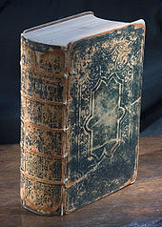
О Библии кратко
The Bible refers to collections of sacred scripture of Judaism and Christianity.
There is no single version: both the individual books (Biblical canon) and their order vary. The Hebrew Bible contains 39 books, while Christian Bibles range from the 66 books of the Protestant canon to 81 books in the Ethiopian Orthodox Bible. The oldest surviving Christian Bibles are Greek manuscripts from fourth century AD; the oldest Hebrew manuscripts date from the Middle Ages
The Hebrew Bible, or Tanakh, is divided into three parts: (1) the five books of the Torah ("teaching" or "law") comprise the origins of the Israelite nation and its covenant with God; (2) the Nevi'im ("prophets") containing the historic account of ancient Israel and Judah plus works of prophecy; and (3) the Ketuvim ("writings"), poetic and philosophical works such as Psalms and Job. Christian Bibles include the books of the Hebrew Bible, but arranged in a different fashion: Hebrew Scripture ends with the people of Israel restored to Jerusalem and the temple and the Christian arrangement ends with the book of the prophet Malachi.
The Christian Bible is divided into two parts. The first is called the Old Testament, containing the 39 books of Hebrew Scripture, and the second portion is called the New Testament, containing 27 books. Soon after the establishment of Christianity in the first century, Church Fathers compiled Gospel accounts and letters of apostles into a Christian Bible which became known as the New Testament. The Old and New Testaments together are commonly referred to as "The Holy Bible". The canonical composition of the Jewish Bible is in dispute between Christian groups: Protestants hold only the books of the Hebrew Bible to be canonical; Roman Catholics and Eastern Orthodox additionally consider the deuterocanonical books, a group of Jewish books, to be canonical. The New Testament is composed of the Gospels ("good news"), the Acts of the Apostles, the Epistles (letters), and the Book of Revelation. The Bible is the best-selling book in history with approximate sales estimates ranging from 2.5 billion to 6 billion.
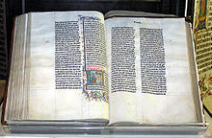
A Bible handwritten in Latin, on display in Malmesbury Abbey, Wiltshire, England. This Bible was transcribed in Belgium in 1407 for reading aloud in a monastery.
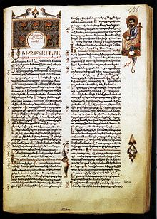
A gospel (from Old English, gōd spell cf Germanic gut + speil "good news") is a writing that describes the life, ministry, death, burial, and resurrection of Jesus. The word is primarily used to refer to the four canonical gospels: the Gospel of Matthew, Gospel of Mark, Gospel of Luke and Gospel of John although it is also used for non-canonical writings such as the Gospel of Thomas. The term "Gospel" refers also to the message itself of the four Gospels or of the whole New Testament.
First page of the Gospel of Mark in Armenian, by Sargis Pitsak, 14th century.

Слова для заучивания

- Athos Афон
- Babylon, Babel Вавилон
- Vatican Ватикан
- Bethlehem Вифлеем
- Gethsemane Гефсимания
- Calvary Голгофа
- Jerusalem Иерусалим
- Jordan Иордан
- Aaron Аарон
- Abraham Авраам
- Adam Адам
- Eve Ева
- Jesus Christ Иисус Христос
- John the Forerunner Иоанн Предтеча
- Joseph, Iosif Иосиф
- Herod Ирод
- Judah, Jude Иуда
- Cain Каин
- Luke Лука
- Mary Мария
- Mark Марк
- Moses Моисей
- Noah Ной
- Pontius Pilate Понтий Пилат
- Belief, faith вера
- Believe in God верить в Бога
- Believer верующий
- Unbeliever неверующий
- Confession исповедание,исповедь
- Christianity христианство
- Christian христианин(-ка)
- The Lord, Our Lord Господь Бог,Иисус Христос
- The Virgin, the Blessed Virgin Mary, Our Lad Богородица,Пресвятая Дева Мария
- Trinity, the three forms of God( the Father, the Son and Holy Ghost Spirit) Троица,Бог-Отец,Бог-сын и Бог-дух святой
- Holy Family святое семейство
- Evangelists Matthew евангелисты Матфей
- Prophet пророк
- Archangel архангел
- Angel ангел
- Cherub херувим
- Seraph серафим
- Martyr мученик(-ца)
- Saint вятой, праведник, Святой(-ая)
- Bible Библия
- Gospel Евангелие
- Gospeller евангелист
- The Ten Commandments 10 заповедей
- Bless благославлять
- Blessing благословение
- Paradise рай
- Doomsday судный день, конец света
- Satan сатана
- Devil дьявол, черт
- Hell ад
- Orthodox Church православная церковь
- Pagan язычник
- The Right Reverend его преосвященство(о епископе)
- Very Reverend его высокопреподобие(о настоятеле собора)
- Patriarch патриарх
- Metropolitan митрополит
- Archbishop архиепископ
- Bishop епископ, архиерей
- Archpriest протоиерей
- Archdeacon протодькон
- Deacon дьякон
- Clergyman, cleric священник, духовное лицо
- Priest священник
- Preacher проповедник
- Church церковь,храм
- Chapel часовня, молельня
- Belfry колокольня
- Monastery мужской монастырь
- Monk монах
- Nun монахиня
- Parish церковный приход
- Parishioner прихожанин(-ка)
- Churchman верующий
- Chancel алтарь
- Altar престол
- Holy bread просвира,просфора
- Eucharist святой хлеб и вино
- Holy oil миро, святой елей
- Holy table престол
- Holy doors царские врата
- Icon, ikon икона
- Iconostasis иконостас
- Mass месса, литургия, обедня
- Service богослужение, служба
- Marriage service венчание
- Baptismal service крестины
- Christian Baptism, christening крещение
- Christen крестить
- Burial service отпевание
- Sermon проповедь
- Preach проповедовать
- Prayer молитва
- Prayer- book молитвенник
- Grace молитва перед трапезой и после неё
- To say Grace прочесть молитве перед и после трапезы
- Pray молиться
- To make the sign of the cross, to bless oneself перекреститься
- Holy Communion святое причастие
- Communicant причастник
- Confession исповедь
- Confessional исповедальня
- Confessant исповедующийся
- Repent каяться
- Sin грех
- Remission of sins отпущение грехов
- Christmas рождество Христово
- Easter Пасха
- Whitsun Троица
- Twelfth day, Epiphany Крещение Господне
- Ascension Day Вознесение
- Holy Cross Day Воздвижение
- The Annunciation, Lady Day Благовещение
- Assumption Успение
- Lent Великий пост

Грамматика: глаголы/ местоимения
Древнеанглийские глаголы
Архаичные глагольные окончания.
The present singular : -(e)th
- He hath / hast = has – имеет
- He moveth = moves - движется
- He doeth = does - делает(или вспомогательный глагол)
- He compasseth = compasses - направляет
The past singular : -(e)st
Thou

The future
Для указания на будущее время для всех лиц использовался вспомогательный глагол shall
- The Father which seeth in secret himself shall reward thee openly(Mt.6:4)
- Ask, and it shall be given you; seek, and ye shall find.(Mt.7:7)
Форма shalt - 2 лицо, ед. число очень активно использовалась в указаниях, повелениях, предписаниях.
1.Thou shalt have no other gods befor me…(Ex.20:3,13-14)
2.Thou shalt not kill.
3.Thou shalt not commit adultry.
Следует помнить, что shall и will могут выступать в качестве самостоятельных модальных глаголов и тогда shall обозначает приказ, принуждение, угрозу, а will – намерение сделать что-либо, волеизъявление или вежливую просьбу.
My son shall not go I will go

Глагол to be (архаичные формы)

The present
I am I am Alpha and Omega.
Thou art
Thou art neither cold nor hot.
He,she,it is Man is born unto trouble.
We,ye,they are
Ye are the salt of the earth.
The past
I,he,she,it was I was in the spirit.
Thou wast Thou wast slain.
We,ye,they were
His eyes were as a flame of fire.

Назовите глаголы архаичной формы настоящего, прошедшего времени и переведите их на русский язык. Образуйте глаголы архаичных форм.

Moveth
Compasseth
Goeth
Shalt
answereth
saith
taketh
leadeth
cometh
gavest
sendeth
findeth
sleepest

Местоимения «высокого стиля»
- thee = you - тебя, тебе
- thou = you - ты
- thy, thine = your - твой, твоя, твое
- thyself- себя, себе
- ye = you - вы

Тексты с заданиями.
Вставьте слова в текст по смыслу
2:1 Now, after was born in of Judea in the days of the king, behold, there came wise men from the east to Jerusalem,
2:2 Saying, Where is he that is born king of the Jews? for we have seen his star in the east, and have come to worship him.
2:3 When Herod the king had heard [these things], he was troubled, and all with him.
2:4 And when he had assembled all the chief priests and scribes of the people, he inquired of them where should be born.
2:5 And they said to him, In Bethlehem of Judea: for thus it is written by the ,
2:6 And thou Bethlehem, [in] the land of Judah, art not the least among the princes of Judah: for out of thee shall come a Governor, that shall rule my people Israel.
2:7 Then Herod, when he had privately called the wise men, inquired of them diligently what time the star appeared.
2:8 And he sent them to Bethlehem, and said, Go, and search diligently for the young child; and when ye have found [him], bring me word again, that I may come and worship him also.
2:9 When they had heard , they departed; and lo, the star, which they saw in the east, went before them, till it came and stood over where the young child was.
2:10 When they saw , they rejoiced with exceeding great joy.
2:11 And when they had come into the house, they saw the young child with his mother, and fell down, and worshiped him: and when they had opened their treasures, they presented to him gifts; gold, and frankincense, and myrrh.
2:12 And being warned by in a dream that they should not return to Herod, they departed into their own country another way. the king Jerusalem Bethlehem the star Mary prophet Jesus Herod Christ God
Вставьте слова в текст по смыслу
3:1 In those days came John , preaching in the wilderness of Judea,
3:2 And saying, Repent ye: for the kingdom of heaven is at hand.
3:3 For this is he that was spoken of by Isaiah, saying, The voice of one crying in the wilderness, Prepare ye the way of , make his paths straight.
3:4 And the same John had his raiment of camel's hair, and a leathern girdle about his loins; and his food was locusts and wild honey.
3:5 Then went out to him , and all Judea, and all the region about Jordan,
3:6 And were by him in Jordan, confessing their sins.
3:7 But when he saw many of the Pharisees and Sadducees come to his baptism, he said to them, O generation of vipers, who hath warned you to flee from the wrath to come?
3:8 Bring forth therefore fruits meet for repentance:
3:9 And think not to say within yourselves, We have for [our] father: for I say to you, that God is able of these stones to raise up children to Abraham.
3:10 And now also the ax is laid to the root of the trees: therefore every tree which bringeth not forth good fruit is hewn down, and cast into the fire.
3:11 I indeed baptize you with water to repentance: but he that cometh after me is mightier than I, whose shoes I am not worthy to bear: he shall baptize you with , and [with] fire:
3:12 Whose fan [is] in his hand, and he will thoroughly cleanse his floor, and gather his wheat into the granary; but he will burn the chaff with unquenchable fire.
3:13 Then cometh from Galilee to Jordan to John, to be baptized by him.
3:14 But John him, saying, I have need to be baptized by thee, and comest thou to me?
3:15 And Jesus answering said to him, Suffer [it to be so] now: for thus it becometh us to fulfill all righteousness. Then he suffered him. 3:16 And Jesus, when he was baptized, went up immediately out of the water: and lo, the heavens were opened to him, and he saw the Spirit of God descending like a dove, and lighting upon him:
3:17 And lo, a voice from heaven, saying, This is my beloved , in whom I am well pleased.
Jerusalem the Baptist the Holy Spirit Abraham Son Jesus the prophet baptized the Lord forbad

Персонажи из Ветхого завета

Aaron
Abraham
Adam
Eve
Joseph, Iosif
Cain
Luke
Moses
Noah

Персонажи из Нового завета

- Jesus Christ
- John the Forerunner
- Joseph, Iosif
- Herod
- Judah, Jude
- Luke
- Mary
- Mark
- Pontius Pilate
- Evangelists Matthew

Священники:

- Patriarch
- Metropolitan
- Archbishop
- Bishop
- Archpriest
- Archdeacon
- Deacon
- Clergyman, cleric
- Priest
- Preacher
- Monk
- Nun

1:1 In the beginning created the heaven and the earth.
1:2 And was without form, and void; and darkness was upon the face of the deep. And oved upon the face of the waters.
1:3 And God said, Let there be light: and there was light.
1:4 And God saw the light, that it was good: and God divided the light from the darkness.
1:5 And God called the light Day, and the darkness he called .And the evening and the morning were the first day.
1:6 And God said, Let there be a firmament in the midst of the waters, and let it divide the waters from the waters.
1:7 And God made , and divided the waters which were under the firmament from the waters which were above the firmament: and it was so.
1:8 And God called the firmament Heaven. And the evening and were the second day.
1:9 And said, Let the waters under the heaven be gathered together unto one place, and let the dry land appear: and it was so.
1:10 And God called the dry land Earth; and the gathering together of the waters called he : and God saw that it was good.
1:11 And God said, Let bring forth grass, the herb yielding seed, and the fruit tree yielding fruit after his kind, whose seed is in itself, upon the earth: and it was so.
1:12 And the earth brought forth grass, and herb yielding seed after his kind, and the tree yielding fruit, whose seed was in itself, after his kind: and God saw that it was good.
1:13 And the evening and the morning were .
1:14 And God said, Let there be lights in the firmament of the heaven to divide the day from the night; and let them be for signs, and for seasons, and for days, and years: 1:15 And let them be for lights in the firmament of the heaven to give light upon the earth: and it was so.
1:16 And God made ; the greater light to rule the day, and the lesser light to rule the night: he made also.
1:17 And God set them in the firmament of the heaven to give light upon the earth, 1:18 And to rule over the day and over the night, and to divide the light from : and God saw that it was good.
1:19 And the evening and the morning were .
1:20 And God said, Let the waters bring forth abundantly the moving creature that hath life, and fowl that may above the earth in the open firmament of heaven.
1:21 And God great whales, and every living creature that moveth, which the waters brought forth abundantly, after their kind, and every winged fowl after his kind: and God saw that it was good.
1:22 And God them, saying, Be fruitful, and multiply, and fill the waters in the seas, and let fowl multiply in the earth.
1:23 And the evening and the morning were the fifth day.
1:24 And God said, Let the earth bring forth the living creature after his kind, cattle, and creeping thing, and beast of the earth after his kind: and it was so.
1:25 And God made the beast of the earth after his kind, and cattle after their kind, and every thing that creepeth upon the earth after his kind: and God saw that it was good.
1:26 And God said, Let us make man in our image, after our likeness: and let them have dominion over the fish of the sea, and over the fowl of the air, and over the cattle, and over all the earth, and over every creeping thing that creepeth upon the earth.
1:27 So God created man.
1:28 And God them, and God said unto them, Be fruitful, and multiply, and replenish the earth, and subdue it: and have dominion over of the sea, and over the fowl of the air, and over every living thing that moveth upon the earth.
1:29 And God said, Behold, I have given you every herb bearing seed, which is upon the face of all the earth, and every , in the which is the fruit of a tree yielding seed; to you it shall be for meat.
1:30 And to every beast of the earth, and to every fowl of the air, and to every thing that creepeth upon the earth, wherein there is life, I have given every green herb for meat: and it was so.
1:31 And God saw every thing that he had made, and, behold, it was . And the evening and the morning were the sixth day.

4:1 And knew Eve his ; and she conceived, and bare , and said, I have gotten a man from
.
4:2 And she again bare his brother Abel. And was a keeper of sheep, but Cain was a tiller of the ground.
4:3 And in process of time it came to pass, that Cain brought of of the ground an offering unto the LORD.
4:4 And Abel, he also brought of the firstlings of his flock and of the fat thereof. And the LORD had respect unto Abel and to his offering: 4:5 But unto Cain and to his offering he had not respect. And Cain was very wroth, and his countenance fell.
4:6 And the LORD said unto Cain, Why art thou wroth? and why is thy countenance fallen?
4:7 If thou doest well, shalt thou not be accepted? and if thou doest not well, sin lieth at the door. And unto thee shall be his desire, and thou shalt rule over him.
4:8 And Cain talked with Abel his : and it came to pass, when they were in the field, that Cain rose up against Abel his brother, and slew him.
4:9 And the LORD said unto Cain, Where is Abel brother? And he said, I know not: Am I my brother's keeper? 4:10 And he said, What hast thou done? the voice of thy brother's crieth unto me from the ground.
4:11 And now art thou cursed from the earth, which hath opened her mouth to receive thy brother's blood from thy hand; 4:12 When thou tillest the ground, it shall not henceforth yield unto thee her strength; a fugitive and a vagabond shalt thou be in the earth.
4:13 And Cain said unto the LORD, is greater than I can bear.
4:14 Behold, thou hast driven me out this day from the face of the earth; and from thy face shall I be hid; and I shall be a fugitive and a vagabond in the earth; and it shall come to pass, that every one that findeth me shall slay me.
4:15 And the LORD said unto him, Therefore whosoever slayeth Cain,vengeance shall be taken on him sevenfold. And the LORD set a mark upon Cain, lest any finding him should kill him.

The yearly cycle of the twelve feasts Двунадесятые праздники:
- The Nativity of the Holy Virgin - Рождество Пресвятой Девы Марии.
- The Elevation of the Venerable and Vivifying Cross - Воздвижение Честнаго и Животворящего Креста. The Exaltation of the Precious and Life-giving Cross.
- The Presentation in the Temple of our Most Holy Lady - Введение во храм Пресвятой Богородицы.
- Christmas (west.) зап. - Рождество, The Nativity of our Lord, God and Saviour - Рождество Господа Бога и Спаса нашего Иисуса Христа.
- Epiphany - Крещение, Богоявление; Theophany (the Manifestation of God), the Baptism of the Lord - Крещение Господне.

- The Meeting of our Lord Jesus Christ - Сретение Господа нашего Иисуса Христа (western Candlemas ).
- The Annunciation of the Most Holy Sovereign Lady Theotokos -Благовещение Пресвятой Богородицы.
- The Entry of the Lord into Jerusalem - Вход Господень в Иерусалим, Palm Sunday - Неделя Ваий.
- The Ascension into Heaven of our Lord Jesus Christ - Вознесение Господа нашего Иисуса Христа.
- The Holy Pentecost - Пятидесятница. Trinity Sunday - День Святой Троицы, Whitsunday (west.).
- The Transfiguration of our Lord Jesus Christ – Преображение Господа нашего Иисуса Христа.
- The Dormition (Falling-asleep) of the Most-Holy Mother of God (Orth.) правосл.
- The Assumption of the All-Holy Mother of God (Cath.) кат. – Успение Пресвятой Богородицы, Матери Бога нашего.
Easter - Пасха, Passover (jew.) иуд.

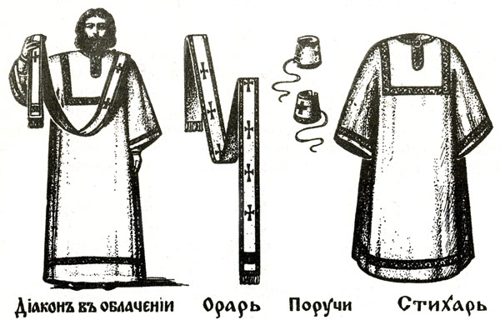
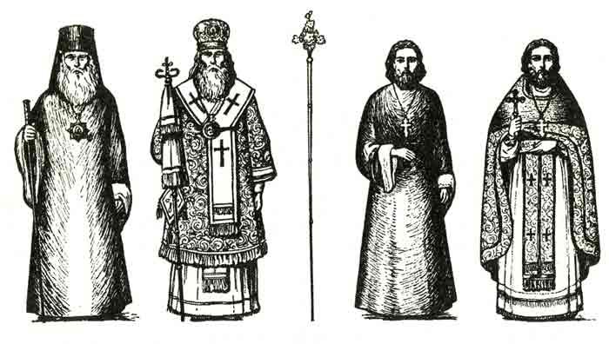
Облачения священнослужителей

Цвета.

Молитвы
Во имя Отца и Сына и Святаго Духа. Аминь.
Господи, благослови!
Господи, помилуй!
Спаси Вас Господи!
С Богом!
Слава Богу!
Слава Тебе, Господи!
Спаси и сохрани!
Пресвятая Богородица, спаси нас!
Господи Иисусе Христе, Сыне Божий, помилуй мя грешнаго!
Глава Тебе, Господи, Слава Тебе.
Ангеле Божий, хранителю мой, моли Бога о мне!
Гвятый Боже, Святый Крепкий. Святый Бессмертный, помилуй нас!
Моли Бога о мне святый угодниче Божий (имя), яко аз усердно к тебе прибегаю, скорому помощнику и молитвеннику о душе моей. Аминь.
Царю Небесный, Утешителю, Душе; истины, Иже везде сый и вся исполняли. Сокровище благих и жизни Подателю, прииде и вселися в ны и очисти ны от всякия скверны и спаси, I Блаже, души наша.
Достойно есть яко воистину блажити Тя Богородицу, Присноблаженную и Пренепорочную и Матерь Бога; нашего. Честнейшую Херувим и славнейшую без сравнения Серафим, без нетления Бога Слова рождшую, сущую Богородицу Тя величаем.

In the name of the Father and of the Son, and of the Holy Spirit! Amen.
Bless, О Lord!
Lord, Have Mercy!
May the Lord save you!
God be with you!
Glory to God!
Glory to Thee, О Lord!
Lord, save and protect!
Most Holy Mother of God, save us!
Lord Jesus Christ, Son of God, have mercy on me, a sinner.
Glory to Thee, our God, Glory to Thee!
Oh, Angel of the Lord, my Guardian, pray to God forme!
Holy God! Holy Mighty! Holy Immortal! Have mercy on us.
Holy Saint (name), pray to God for me, for I run to Thee, Speedy Helper and Protector of my soul. Amen.
Oh, Heavenly King, the Comforter, Spirit of truth, who art in all places and fillest all things, Treasuiy of good things and Giver of life, come and take up Thine abode in us and cleanse us from every stain and save our souls, oh Good one.
It is truly meet to bless Thee, О Theotokos, ever-blessed and most blameless and the Mother of our God. More Honourable than the Cherubim and beyond compare More Glorious t Ivan t he Seraphim, Thee Who without difilement gavest birth to God the Word, true Mother of God, Thee do we magnify.

РУССКАЯ ПРАВОСЛАВНАЯ ЦЕРКОВЬ СВЯЩЕННОСЛУЖИТЕЛИ И ОБРАЩЕНИЯ К НИМ

His Holiness Patriarch of Moscow and all Russia
Его Святейшество Патриарх Московский и всея Руси -
Ваше Святейшество -
Владыко -Митрополит -
Ваше Высокопреосвященство -Владыко -Архиепископ -
Ваше Высокопреосвященство -
Владыко -Епископ -
Ваше Преосвященство
Владыко -Архимандрит -
Ваше Высокопреподобие -
Отец-Игумен -
Ваше Высокопреподобие -
Отец -Протоиерей -
Ваше Высокопреподобие -
Отец-Иеромонах -
Ваше Преподобие -
Отец-Иерей -
Ваше Преподобие -
Отец-
Архидиакон-
Ваше высокопреподобие -
Отец (архидиакон) -
Протодиакон -
Ваше Высокопреподобие -
Отец (протодиакон) -
Иеродиакон -
Ваше Преподобие -Отец (иеродиакон) -
Диакон -Ваше Преподобие -Отец (диакон) -

Your Holiness Vladiko Metropolitan
Your Eminence, Your Grace Vladiko
Archbishop
Your Eminence
Vladiko Bishop
Your Excellency
Vladiko Archimandrite
Very Reverend Father Father Hegumenos, hegumen

Very Reverend Father Father Archpriest
Very Reverend Father
Father Hiermonk (priest-monk)
Reverend Father
Father Priest
Reverend Father

Father
Archdeacon
(senior deacon-monk) Veiy Reverend Father Father (archdeacon)
Protodeacon
(senior deacon)
Veiy Reverend Father Father (protodeacon)
Hierodeacon
(deacon-monk) Reverend Father Father (hierodeacon)
Deacon
Reverend Father Father (deacon)
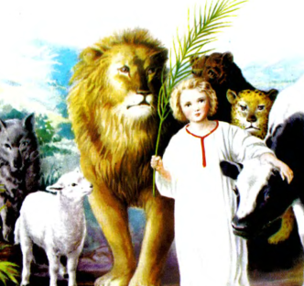
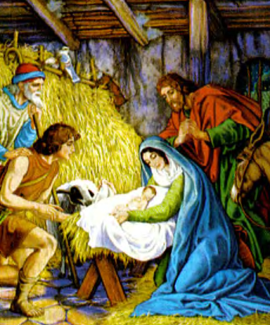
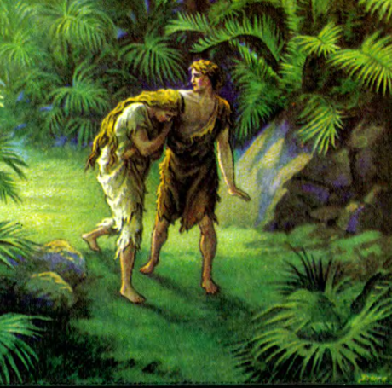
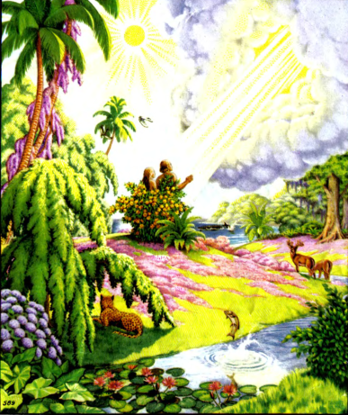
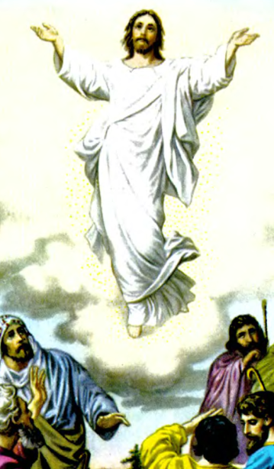
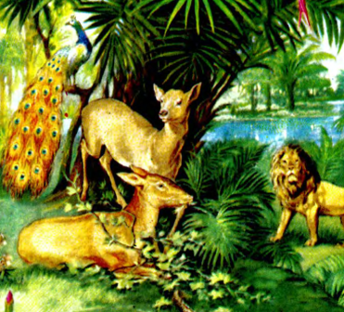
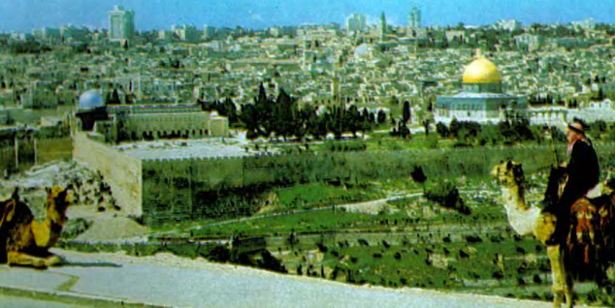
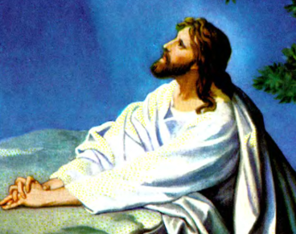
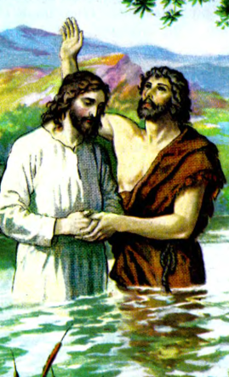
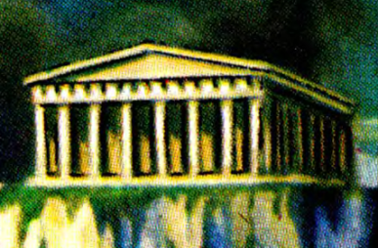
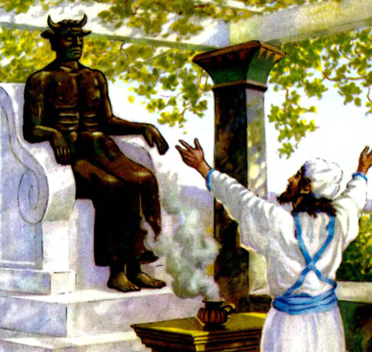
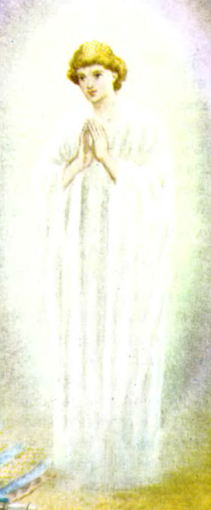
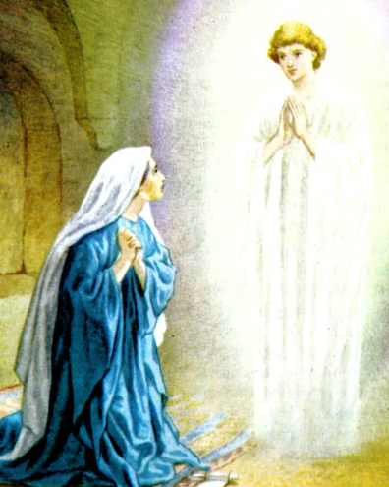
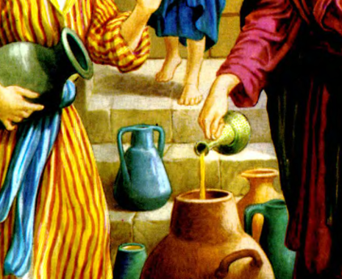
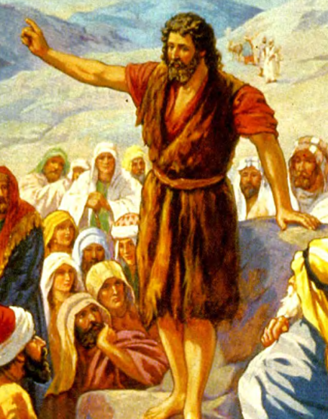
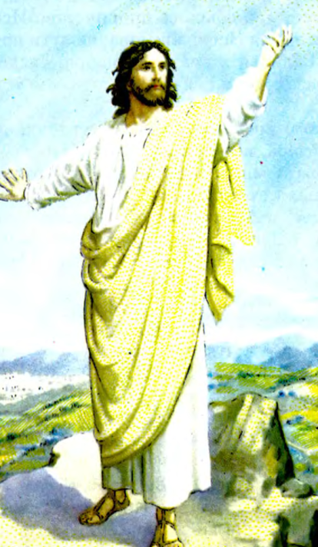
Персоналии

